Starting from opening the workbook, the hash is created:

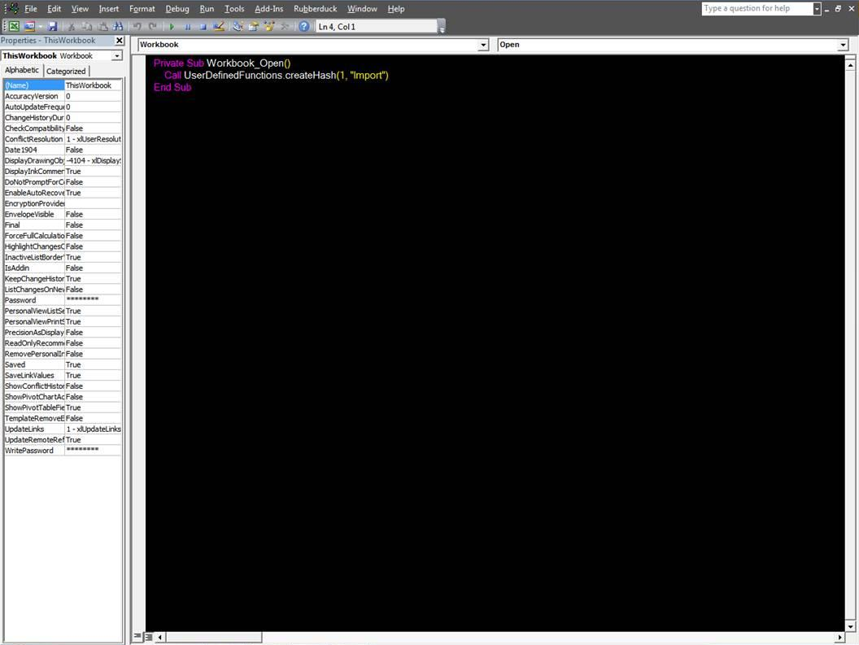

Code for creating the hash and placing the timestamp:

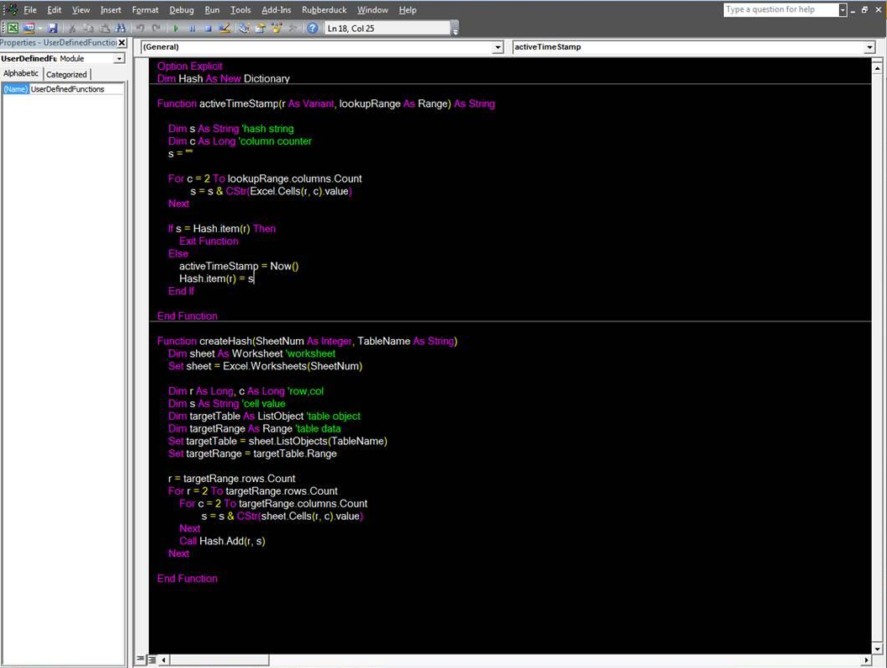

In this picture you can see the formula/user defined timestamp function in the selected cell (first column, 6th row).

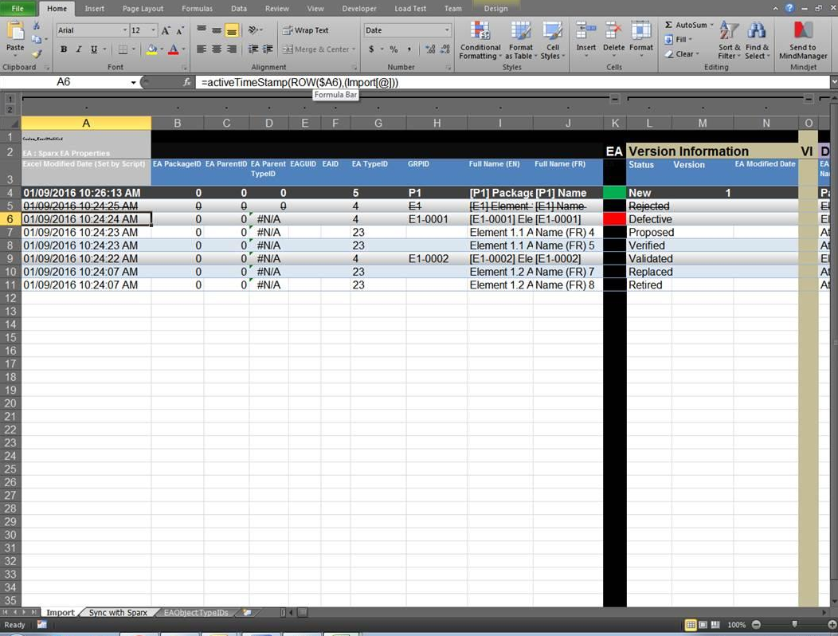

Comparing the following picture to the previous one, you can see in the 4th row, column M when the version is changed from 1 to 3, the timestamp function which is in the first column, 4th row updates because the string hash has changed.

